Lab3

Q1. Ping Basics

* 1. Explain the purpose of the ping utility and its basic syntax.

The ping utility is a network diagnostic tool used to determine if a host on an IP network is reachable. It helps in checking the operational status of network devices, such as servers or routers, and in measuring the connection's latency (delay).

Syntax : ping [options] destination

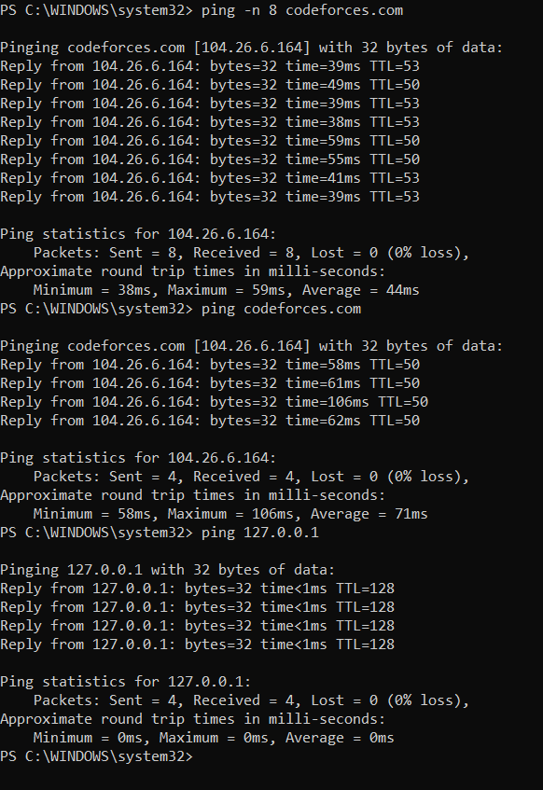

Q2. Ping Output Analysis

Run the command ping (link unavailable) and capture the output.

* ping codeforces.com > output.txt

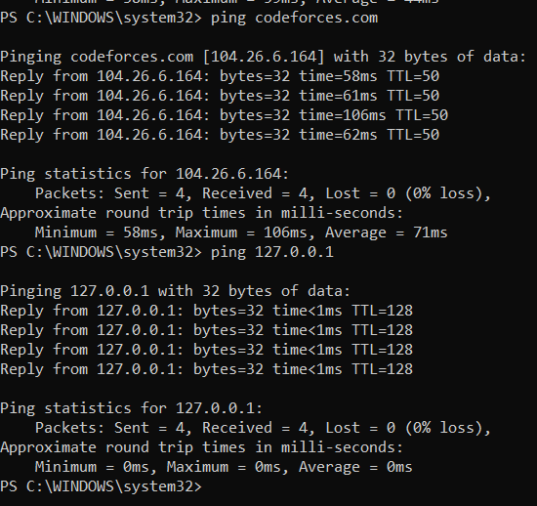

**Round-Trip Time (RTT):** This measures the duration it takes for a packet to travel from the source to the destination and return. Lower RTT values suggest faster connections, while higher RTT might indicate network congestion or greater distance from the server.

**TTL (Time to Live):** TTL is a value embedded in an IP packet that determines the maximum number of hops (routers or devices) the packet can traverse before being discarded. The sending host sets the initial TTL value, and it decreases by 1 with each hop.

**Pinging google.com [104.26.6.164] with 32 bytes of data:**  
**Host Information:** This line shows that the ping utility is attempting to send ICMP Echo Request packets to google.com, which resolves to the IP address 142.250.72.238.

**Ping statistics for 142.250.72.238:** This section summarizes the results from the ping test.

**Packets:** Sent = 4, Received = 4, Lost = 0 (0% loss).  
**Sent = 4:** The number of ICMP Echo Request packets that were sent to the destination.  
**Received = 4:** The number of ICMP Echo Reply packets successfully returned from the destination.

**Lost = 0 (0% loss):** This indicates the number (and percentage) of packets that were lost during transmission. Packet loss can be a sign of network issues. In this case, a 0% loss means that all packets were successfully received, indicating a stable connection.

**Approximate round trip times in milliseconds:**

* **Minimum = 58ms:** The shortest round-trip time recorded during the ping test.
* **Maximum = 106ms:** The longest round-trip time recorded during the test.
* **Average = 71ms:** The average round-trip time across all the packets sent.

Q3. Ping Options

-n / -c: The -n option allows you to specify the number of ping requests to send. After sending the specified number of packets, the ping command will automatically stop.

-l /-s : The -s option allows you to specify the size of the ICMP Echo Request packets in bytes. By default, the ping command sends packets with 32 bytes of data (on Windows systems), which corresponds to 32 bytes of data when including the ICMP header.

-i/ -t: he -t option sets the Time to Live (TTL) value for the packets sent by the ping command. TTL is a field in the IP header that indicates the maximum number of hops (routers or devices) that the packet can pass through before being discarded. Each hop decreases the TTL by 1.

-w : The -w option specifies a time limit (in seconds) for how long the ping command should run, regardless of how many packets have been sent or received. Once the deadline is reached, the ping command stops.

**Q4. Using ping for Troubleshooting**

**Step 1: Test Local Network Connectivity**

**First, verify that the user's machine is properly connected to the local network.**  
Pinging the loopback address (127.0.0.1) ensures that the network stack on the user's machine is functioning correctly. If this fails, it could indicate a problem with the network adapter or the local machine's configuration.

**Step 2: Test Connectivity to the Default Gateway**  
Next, check if the user's machine can reach the default gateway, which is usually the router.  
Run the ping command followed by the default gateway IP. To find the default gateway IP, open the terminal, type ipconfig, and check the Wireless LAN Adapter Wi-Fi section.  
This command tests whether the user's machine can communicate with the local network's gateway. If it fails, there might be an issue with the Ethernet cable, the switch, or the router itself.

**Step 3: Test Connectivity to an External Website**  
If the gateway is reachable, test the connection to an external website like google.com.  
This command checks whether the user's machine can connect to an external site. If you receive a response, it confirms that the machine can reach the internet. If not, there might be an issue with DNS resolution, the internet connection, or the routing beyond the local network.

**Step 4: Diagnose Slow Network Speeds Using Ping**  
If the user can reach external websites but reports slow speeds, measure latency and check for packet loss.  
Running this command sends multiple ICMP Echo Request packets to google.com and measures the round-trip time (RTT) and packet loss. This step helps determine if high latency or packet loss is contributing to the slow network speeds.

* **High RTT:** If the RTT is consistently high (e.g., above 100ms), the slowness could be due to network congestion, the distance to the server, or issues with the ISP.
* **Packet Loss:** Any packet loss indicates an unstable connection, which could be causing the slow speeds. Packet loss might result from faulty network hardware, issues with the ISP, or network congestion.

**Step 5: Identify Intermittent Issues with a Long-Term Ping Test**  
If the problem seems intermittent, perform a longer ping test to capture more data over time.  
Running a longer ping test can help identify intermittent connectivity issues by providing more extensive data points.

**Step 6: Use the TTL Option for Advanced Routing Diagnostics**  
If you suspect routing issues, the TTL (Time to Live) option can help diagnose how far packets are traveling. By setting a low TTL value, you limit the number of hops a packet can take before being discarded. If the packet doesn’t reach its destination and the TTL expires, you'll receive a message indicating where the packet was dropped, which can help identify routing problems.

Q5.

from scapy.all import IP, ICMP, sr1

import time

def ping(dest_ip, count=4, ttl=64, packet_size=64, timeout=2):

try:

if count <= 0 or ttl <= 0 or packet_size < 0:

raise ValueError("Invalid value for count, TTL, or packet size.")

rtt_times = []

packet_sent = 0

packet_received = 0

for i in range(count):

packet_sent += 1

pkt = IP(dst=dest_ip, ttl=ttl)/ICMP()/("X"*packet_size)

start_time = time.time()

reply = sr1(pkt, verbose=False, timeout=timeout)

end_time = time.time()

if reply:

packet_received += 1

rtt = (end_time - start_time) * 1000

rtt_times.append(rtt)

print(f"{i+1}: Reply from {dest_ip}: bytes={len(reply)} time={round(rtt, 2)}ms TTL={reply.ttl}")

else:

print(f"{i+1}: Request timed out.")

# Calculate statistics

packet_loss = ((packet_sent - packet_received) / packet_sent) * 100

if rtt_times:

avg_rtt = sum(rtt_times) / len(rtt_times)

min_rtt = min(rtt_times)

max_rtt = max(rtt_times)

else:

avg_rtt = min_rtt = max_rtt = None

print(f"\n--- {dest_ip} ping statistics ---")

print(f"{packet_sent} packets transmitted, {packet_received} received, {packet_loss:.2f}% packet loss")

if avg_rtt is not None:

print(f"rtt min/avg/max = {round(min_rtt, 2)}/{round(avg_rtt, 2)}/{round(max_rtt, 2)} ms")

else:

print("No reply received.")

except ValueError as ve:

print(f"Error: {ve}")

except Exception as e:

print(f"An error occurred: {e}")

if __name__ == "__main__":

# Example usage

dest_ip = "8.8.8.8" # Google's DNS server

ping(dest_ip, count=4, ttl=64, packet_size=64, timeout=2)

